Design Document
These set of design documents are for the digital solution I am proposing for Rolsa Technologies. It is going to include:
- Visual/interface designs
- Data dictionary for the data requirements
- Flowcharts for the selection of algorithm designs
- A test strategy

Flowcharts
I chose to use green and black for the flowcharts to align with the brand colours of the website. Rolsa Technologies specialize in green technology, so using green emphasizes the company’s commitment to sustainability and environmentally friendly solutions.

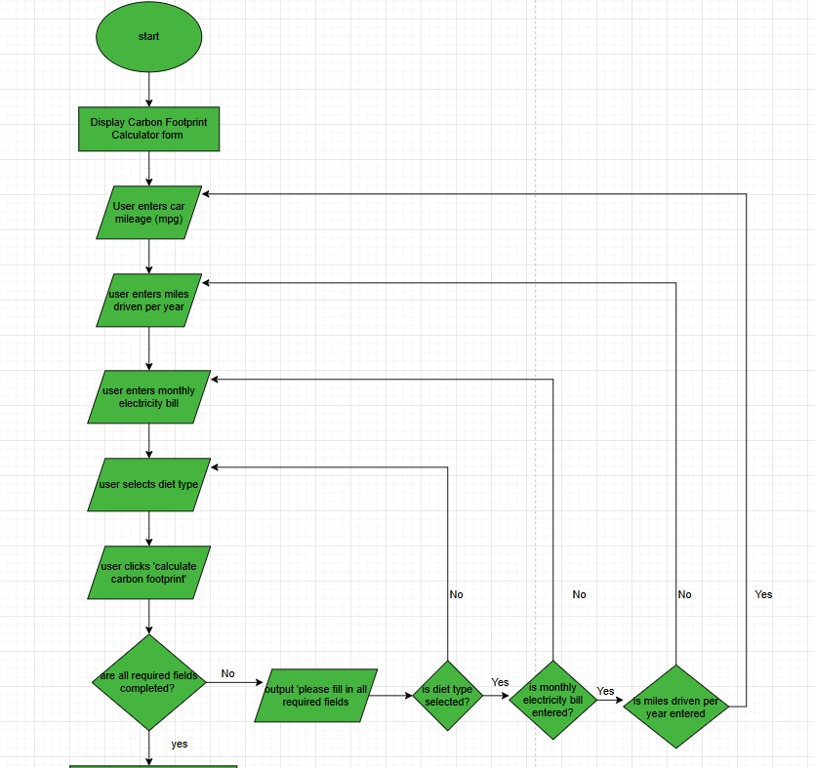
Carbon Footprint Calculator

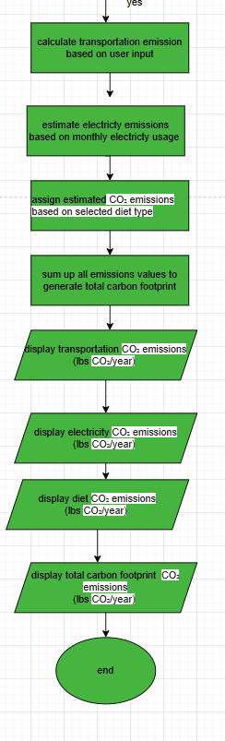
The co2 emissions are calculated using predefined formulas based on industry standards for transportation, electricity usage and diet impact. The flowchart above details the process by which users can calculated their carbon footprint based on input data, such as car mileage, electricity usage and diet

type. The flowchart outlines how the system calculates co2 emissions for each category (transportation, energy and diet) and sums them to provide an overall carbon footprint. It also includes validation checks to ensure that all required fields are completed before performing the calculations. The flowchart helps guide users through the process while ensuring accurate results and displaying the carbon footprint breakdown clearly, making it easy for users to understand their environmental impact.

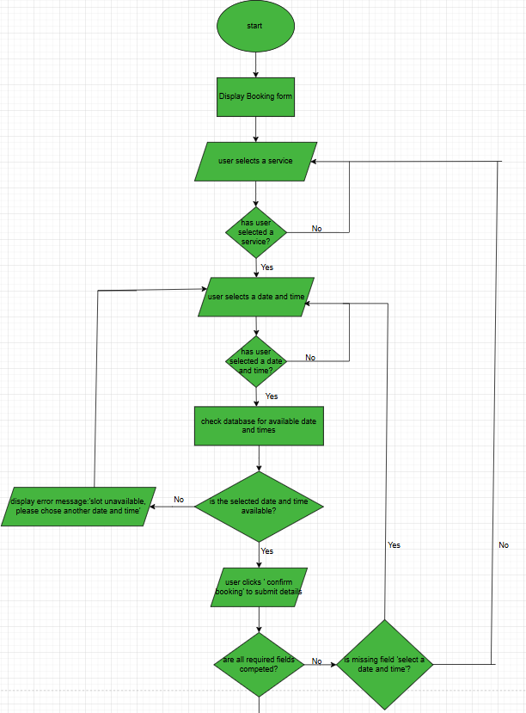
Booking system

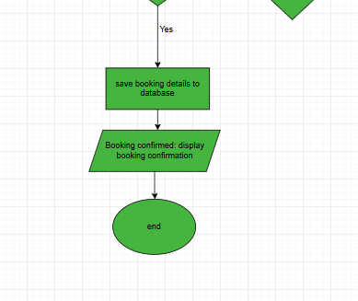
This is the flowchart for the booking system and outlines the entire booking process. It includes checks to ensure that double bookings do not occur and that all the required fields are filled in. the flowchart also handles edge case, such as confirming the availability of the selected date and time, displaying an error if the chosen time is unavailable. The flowchart ensures an efficient and user-friendly booking process. The website will feature a simple, hassle free booking system allowing customers to schedule solar panel and EV charger installations as well as consultations with energy experts therefore I made the process as simple as possible.

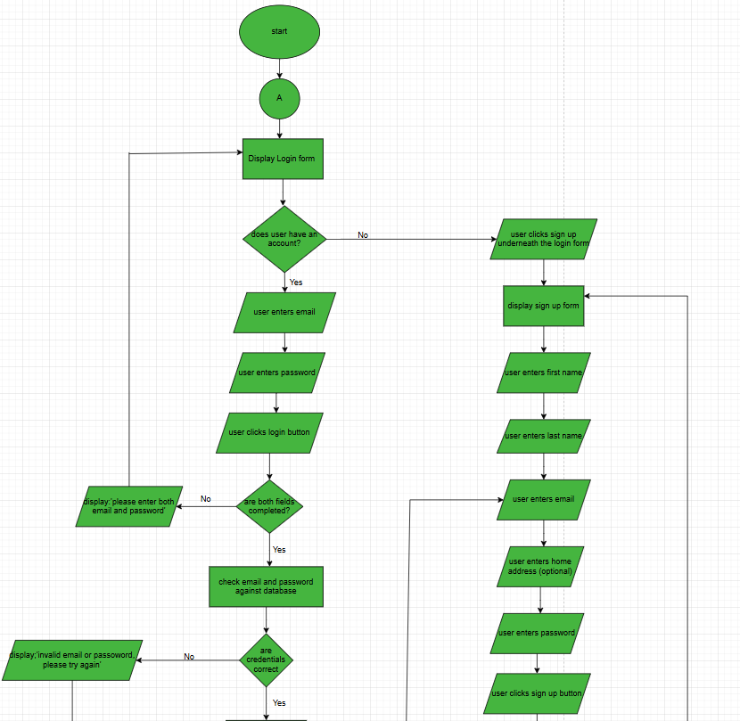
User authentication

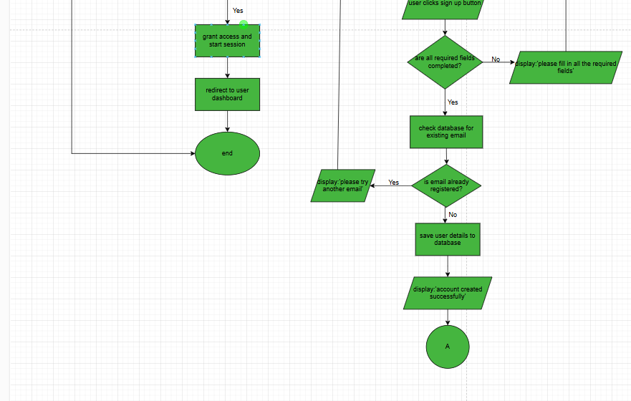
The user authentication flowchart outlines the login and registration process, ensuring a secure and efficient user experience. It includes error handling such as notifying the users of incorrect credentials and duplicate emails. A key feature in the flowchart is the connecter (the a inside the circle symbol) which links the end of the registration process to the login form, allowing new users to seamlessly transition to logging in after account creation. This connection makes the process more intuitive and user friendly.

Data Dictionaries
Effective data design is essential for ensuring the functionality, security and efficiency of Rolsa Technologies’ digital platform. A well-structured data system enables smooth user authentication, secure data management and reliable appointment scheduling. All of which are crucial for an accessible and user-friendly experience.
This section outlines the key data requirements for the platform, including the variables, data structures and data types used in essential features of the website such as user authentication and the booking system.

User Authentication
Field Name | Data Type | Description | Validation/constraints | example
user_id | INT | Unique identifier for each  user | PRIMARY KEY, AUTO-INCREMENT | 102
first_name | VARCHAR  (50) | The users  first name | NOT NULL | Ajae
last_name | VARCHAR  (50) | The users  last name | NOT NULL | Bushay
email | VARCHAR (100) | The users email | NOT NULL | ajbushay @gmail.c  om
address | TEXT | The users home address | NULLABLE | 27  Regents Street,  London
password | VARCHAR (250) | Stores users hashed password for authenticat  ion | NOT NULL
created_at | TIMESTAMP | The timestamp for when the user created the  account | DEFAULT CURRENT_TIMESTAM P | 2025-03-  18  12:38:00
updated_at | TIMESTAMP | The timestamp for the last update  user made | AUTO_UPDATE ON CHANGES | 2025-03-  14  14:29:00

Booking system
Field name | Data type | Description | Validation rules/  constraints | Example
booking_id | INT | Unique identifier for each  booking | PRIMARY KEY, AUTO_INCREMENT | 106
user_id | INT | This links the booking to a registered  user | FOREIGN KEY | 102
service_type | ENUM | The type of services that can be booked (solar panel and EV charger installations or consultation  s) | NOT NULL, must be one of the services in the dropdown | consultatio ns
booking_dat e | DATE | The date of the scheduled  service | NOT NULL, must be a valid date (yyyy:mm:dd) | 2025-04-05
booking_tim e | TIME | The time of the scheduled  service | NOT NULL, must be a valid time (hh: mm: ss) | 14:27:00
booking_stat us | ENUM | The status of the  booking | Must be one of:  ’pending’, ’cancelled  or ‘confirmed’ | Confirmed
created_at | TIMESTA MP | The timestamp of when the booking was  made | DEFAULT CURRENT_TIMESTA MP | 2025-03-13  10:48:00

updated_at | TIMESTA MP | The timestamp of the last modificatio  n | DEFAULT CURRENT_TIMESTA MP ON UPDATE CURRENT_TIMESTA  MP | 2025-05-14  15:21:00

Visual/interface designs
This section covers the key visual elements of the proposed website such as the colour scheme, fonts and overall layout. The goal is to create a design that is not only visually appealing but also user friendly, helping the website meet its purpose, by focusing on a clean and modern style with easy-to-follow design principals. The aim is to make sure that the site is both attractive and easy to use, these visual choices are carefully made to complement the websites functionality and improve the overall user experience.

Homepage
Colour schemes, fonts and text sizes:
Main colours:
- Green (background for the navigation bar and footer)
- black (text)
- another shade of green for the buttons Fonts:
- Roboto for regular text
- Roboto bold for the bold text in wireframe Text sizes:
- Headings will use larger sizes for prominence
- Body text in standard size for readability
Hover effects:
- Buttons: background colour will lighten on hover to provide subtle visual feedback
- Links: links will change colour to a lighter shade on hover to enhance interactivity

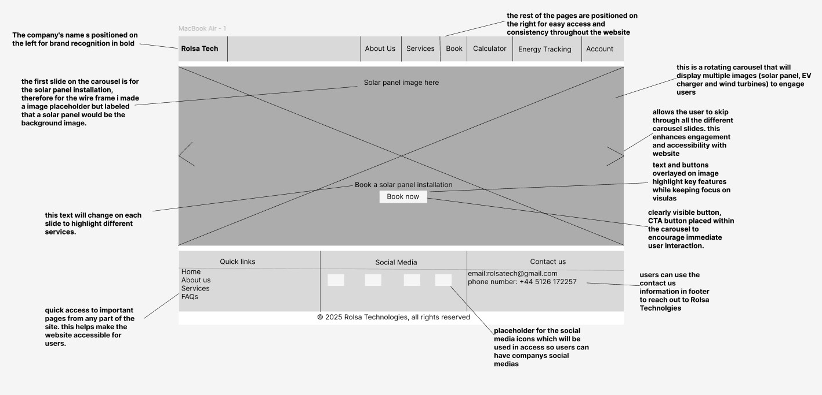

All the annotations in case it isn’t clear in image above:
- The company's name is positioned on the left for brand recognition in bold
- the rest of the pages are positioned on the right for easy access and consistency throughout the website
- the first slide on the carousel is for the solar panel installation, therefore for the wire frame i made a image placeholder but labelled that a solar panel would be the background image.
- this is a rotating carousel that will display multiple images (solar panel, EV charger and wind turbines) to engage users
- arrow allows the user to skip through all the different carousel slides. this enhances engagement and accessibility with website
- text and buttons overlayed on image highlight key features while keeping focus on visuals
- this text will change on each slide to highlight different services.
- clearly visible button, CTA button placed within the carousel to encourage immediate user interaction.
- quick access to important pages from any part of the site. this helps make the website accessible for users.
- placeholder for the social media icons which will be used in access so
users can have company’s social medias
- users can use the contact us information in footer to reach out to Rolsa Technologies

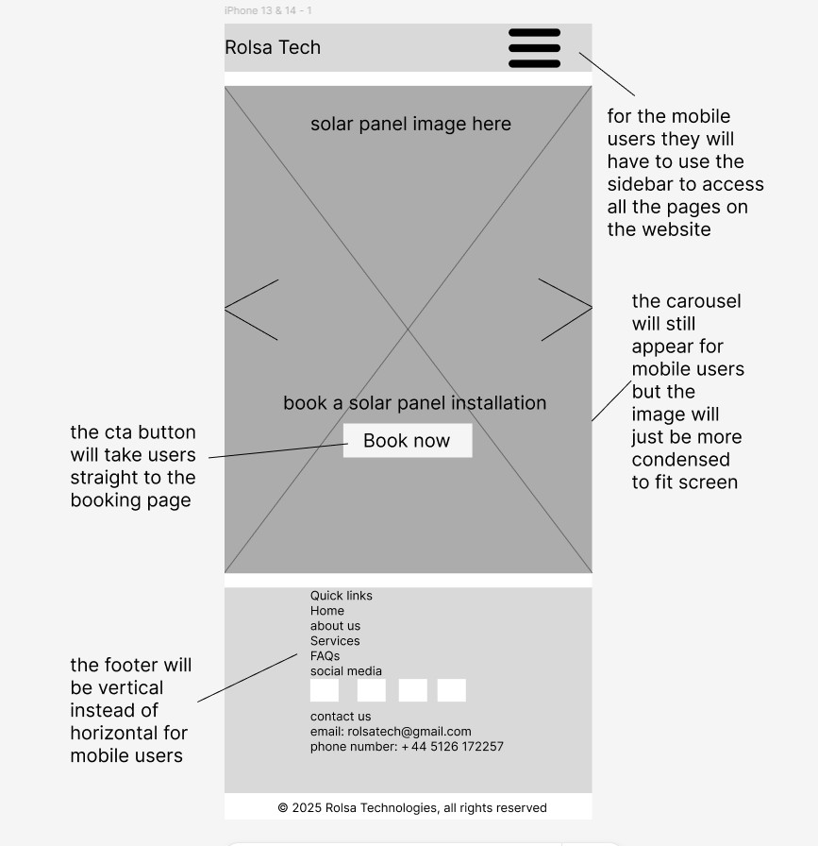
Homepage on mobile device

About us page
Colour schemes, fonts and text sizes:
Main colours:
- Green (background for the navigation bar and footer)
- black (text)
- another shade of green for the buttons
- White (background) Fonts:

- Roboto for regular text
- Roboto bold for the bold text in wireframe Text sizes:
- Headings will use larger sizes for prominence
- Body text in standard size for readability
Hover effects:
- Buttons: background colour will lighten on hover to provide subtle visual feedback
- Links: links will change colour to a lighter shade on hover to enhance interactivity
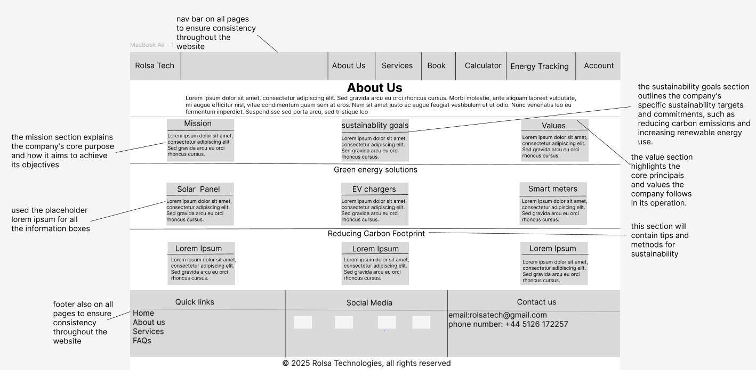

Services page
Colour schemes, fonts and text sizes:
Main colours:
- Green (background for the navigation bar and footer)
- black (text)
- another shade of green for the buttons
- White (background) Fonts:
- Roboto for regular text

- Roboto bold for the bold text in wireframe Text sizes:
- Headings will use larger sizes for prominence
- Body text in standard size for readability
Hover effects:
- Buttons: background colour will lighten on hover to provide subtle visual feedback
- Links: links will change colour to a lighter shade on hover to enhance interactivity
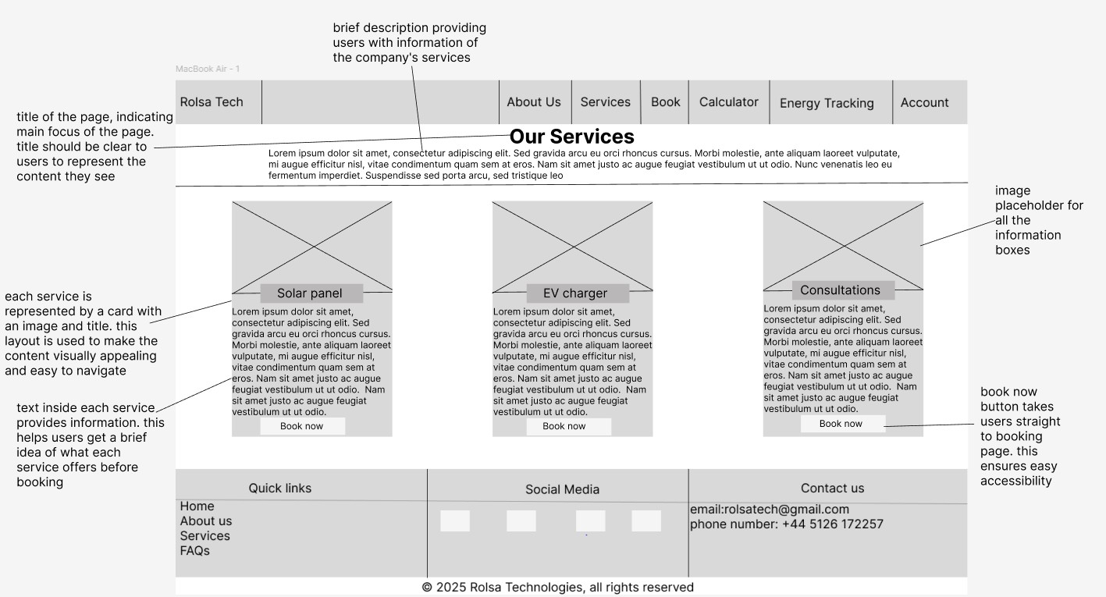

Carbon Footprint Calculator page
Colour schemes, fonts and text sizes:
Main colours:
- Green (background for the navigation bar and footer)
- black (text)
- another shade of green for the buttons
- White (background) Fonts:
- Roboto for regular text
- Roboto bold for the bold text in wireframe Text sizes:

- Headings will use larger sizes for prominence
- Body text in standard size for readability
Hover effects:
- Buttons: background colour will lighten on hover to provide subtle visual feedback
- Links: links will change colour to a lighter shade on hover to enhance interactivity
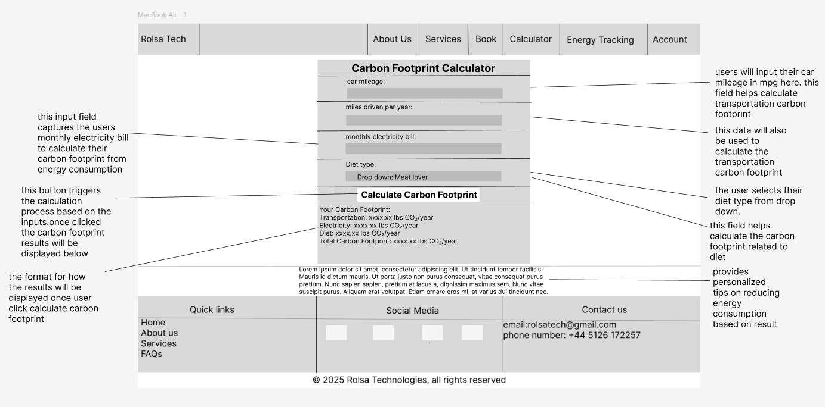

Login
Colour schemes, fonts and text sizes:
Main colours:
- Green (background for the navigation bar, footer and form)
- black (text)
- another shade of green for the buttons
- White (background) Fonts:
- Roboto for regular text
- Roboto bold for the bold text in wireframe Text sizes:
- Headings will use larger sizes for prominence
- Body text in standard size for readability

Hover effects:
- Buttons: background colour will lighten on hover to provide subtle visual feedback
- Links: links will change colour to a lighter shade on hover to enhance interactivity

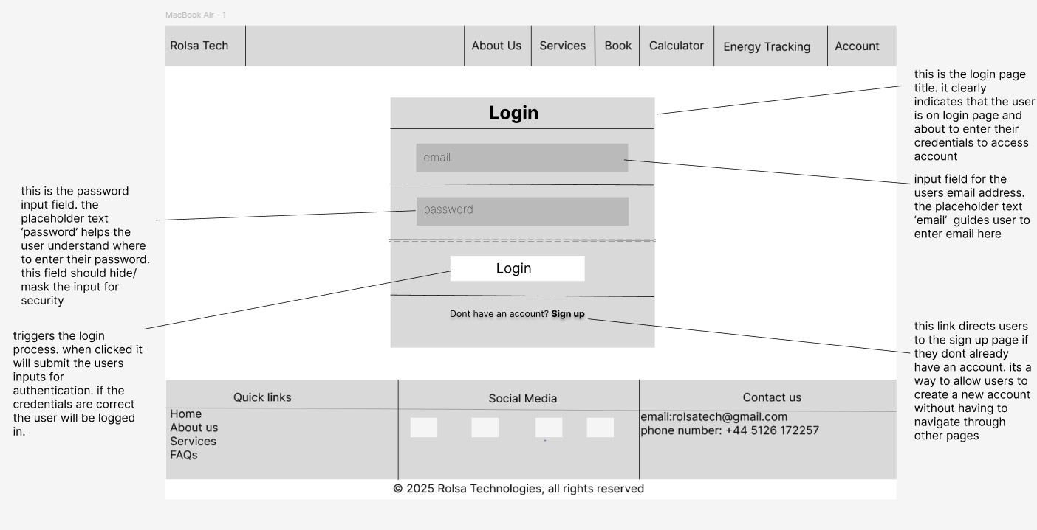

Sign Up page
Colour schemes, fonts and text sizes:
Main colours:
- Green (background for the navigation bar, footer and form)
- black (text)
- another shade of green for the buttons
- White (background) Fonts:
- Roboto for regular text
- Roboto bold for the bold text in wireframe Text sizes:
- Headings will use larger sizes for prominence
- Body text in standard size for readability

Hover effects:
- Buttons: background colour will lighten on hover to provide subtle visual feedback
- Links: links will change colour to a lighter shade on hover to enhance interactivity

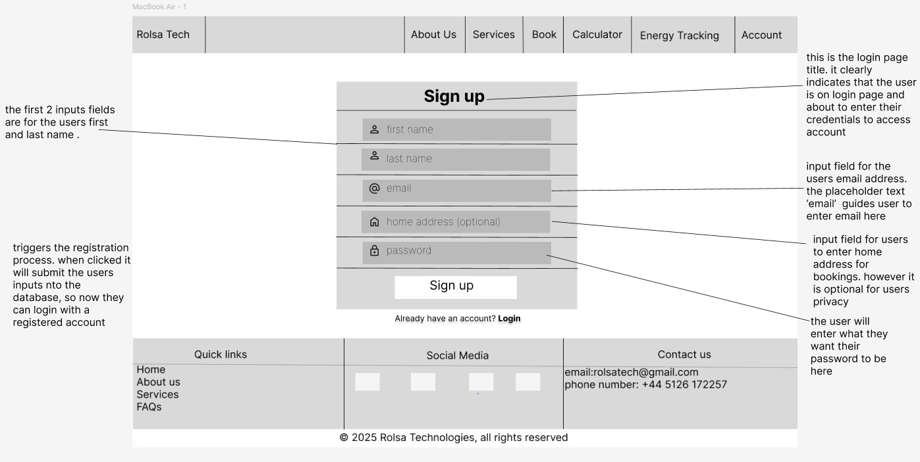

Booking System page
Colour schemes, fonts and text sizes:
Main colours:
- Green (background for the navigation bar, footer and form)
- black (text)
- another shade of green for the buttons
- White (background) Fonts:
- Roboto for regular text
- Roboto bold for the bold text in wireframe Text sizes:
- Headings will use larger sizes for prominence

- Body text in standard size for readability
Hover effects:
- Buttons: background colour will lighten on hover to provide subtle visual feedback
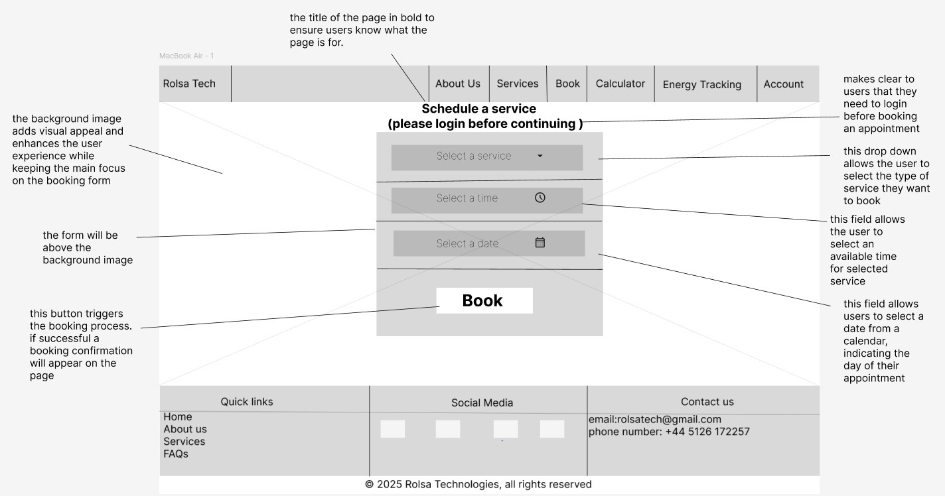
- Links: links will change colour to a lighter shade on hover to enhance interactivity

Energy Tracking page
Colour schemes, fonts and text sizes:
Main colours:
- Green (background for the navigation bar and footer)
- black (text)
- another shade of green for the buttons
- White (background) Fonts:
- Roboto for regular text
- Roboto bold for the bold text in wireframe Text sizes:
- Headings will use larger sizes for prominence
- Body text in standard size for readability

Hover effects:
- Buttons: background colour will lighten on hover to provide subtle visual feedback
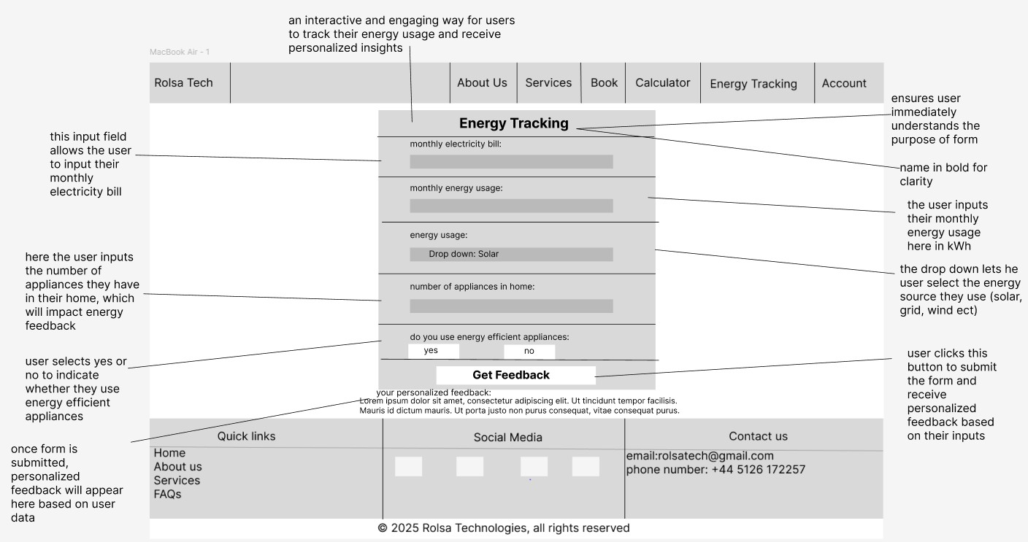
- Links: links will change colour to a lighter shade on hover to enhance interactivity

The test strategy
The test strategy is in the test strategy template

